|  |
| --- |
| **Shipping** |
| Shipping_ID |
| Status |
| Customer_ID |

Verify the accuracy, completeness, and reliability of source data.

**Datasets**

|  |
| --- |
| **Customer** |
| Customer_ID |
| First |
| Last |
| Age |
| Country |

|  |
| --- |
| **Order** |
| Order_ID |
| Item |
| Amount |
| Customer_ID |

The datasets are in different formats, hence loaded all to a python dataframe to perform initial analysis before loading it to SQL table

**Analysis on the datasets:**

* **Customers**
  + Data seems accurate, **no duplicate** records found

SELECT

Customer_id

,First

,Last

,count(*)

FROM [dbo].[PEI_Customer]

group by Customer_id,First,Last

having count(*) > 1

* No customer is in 2 different Country
* Customer data seems **OK** to proceed
* **Order**
  + No Duplicates at Order id level
  + Same Items are purchased by Customers in different orders

SELECT [Item]

,[Customer_ID]

,COUNT(1)

FROM [DataAnalytics].[dbo].[PEI_Order]

GROUP BY [Item],[Customer_ID]

HAVING COUNT(1)>1

* + **Date column is missing**. Hence, **cannot** perform any time variant analysis.
* **Shipping**
  + **Order ID** missing in the shipping table to tag the shipping status of the order.
  + **Date column is missing**. Hence, cannot see the progress of the order status.
  + Data seems **incomplete** without the above 2 columns.

All Customer IDs in Shipping and Orders are **Valid** ids present in Customer table.

SELECT Customer_ID FROM PEI_Order

WHERE Customer_ID NOT IN (SELECT Customer_ID FROM PEI_Customer)

UNION

SELECT Customer_ID FROM PEI_Shipping

WHERE Customer_ID NOT IN (SELECT Customer_ID FROM PEI_Customer)

* 0 Rows returned

However, there are entries in Shipping for Customer_id which **do not** have any records in order table and vice versa.

**For example:**

SELECT

C.Customer_ID

,O.Order_ID

,O.Item

,S.[Status]

FROM dbo.PEI_Customer C

LEFT JOIN PEI_Order O

ON C.Customer_ID = O.Customer_ID

LEFT JOIN dbo.PEI_Shipping S

ON C.Customer_ID = S.Customer_ID

WHERE C.Customer_ID = 185

OR C.Customer_ID = 250

Based on your findings, define and outline the requirements for anticipated datasets, detailing the necessary data components.

**Requirements on existing datasets.**

**Customer**

Data is complete

Additional details like address can be added.

**Order**

**Order Date, Quantity** needs to be added.

**Shipping**

Shipping date needs to be mapped

Order id needs to be added with referential integrity to orders table.

Progress of the shipment can be recorded in the shipping table. With a “Shipment update date”

Anticipated Datasets:

Calendar

Region

Product

Develop the data models to effectively organise and structure the information and provide a detailed mapping of existing data flows, focussing on the areas of concern.

**Data flow**

File sources -> Python / SSIS -> SQL tables

Additional date dimension to be created using table valued functions in SQL to generate a series of dates and then use the DATE functions to create the rest of the columns.

Distinct values of Country from the customer table can be used to create a region table which can be used to join to orders.

Order table need more information like Order_date, Quantity and Country details.

Shipping data needs mapping to order number to identify the status of the order. Order_ID should be foreign key in the table to ensure referential integrity is maintained.

This table should be a SCD table to maintain the status of the order and update the date when the status changes.

**Proposed Data Model**

Region

Date

Customer

Shipping

Orders

Product

A Star schema with Orders fact table and Customer, Region, Product and a date Dimension tables. Shipping can be added as a dimension table of SCD Type 1 or Type 2 depending on the requirement.

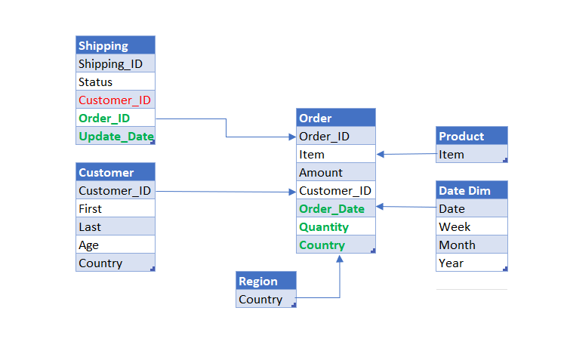

Prepare a story with technical specifications for one part of the data model for a data engineer.

Order Data Analysis

Overview

In order to extract insights from the data set for Orders data with the provided datasets, it is observed that the data in missing column and key mappings. Additional datasets also required to be brought in to make more informed decisions.

Datasets in multiple formats needs to be transformed and loaded to database. This can be done using any ETL too or python.